MANGOCHI CATHOLIC DIOCESE MOCK

EXAMINATIONS
2025 MALAWI SCHOOL CERTIFICATE OF EDUCATION
MATHEMATICS
Subject number: M131/II
Friday, 16 May 2025 Time allowed: 2hrs
8:00 - 10:00 am
PAPER II
(100 marks)

Question Number | Tick if answered | Do not write in these columns
1
2
3
4
5
6
7
8
9
10
11
12
 | Total
Instructions

- This paper contains 13 printed pages. Please check.

- Answer all the six questions in Section A and any four questions from section B.

- The maximum number of marks for each answer is indicated against each question

- Write your answers in the spaces provided on the question paper

- Calculators may be used

- All working must be clearly shown

- Write your Examination Number at the top of each page of your question paper in the spaces provided

- In the table provided on this page,
tick against the Number you have answered

© 2025 MH DIOCESE Turn Over

Section A (60 marks)
Answer all the six questions in the spaces provided

- a. Simplify $\frac{2}{3k^{2}+k-4}÷\frac{4}{k^{2}-1}$ (4 marks)

b. Simplify $\frac{(\sqrt{6}-2\sqrt{7})}{(\sqrt{32}-3\sqrt{3})}$ leaving your answer with a rational denominator.
(5 marks)

- a. Solve the following equation
$log4(2n+1)-log46+log46=log412.5$ (5 marks)

b. Figure 1 shows a circle PQRS with centre O. QS and PR intersect at right angles such that OT=12 cm and TR=4 cm.
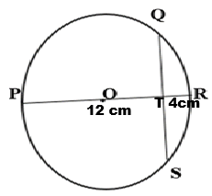
Continued/…
Find the length of QS. (5 marks)

- a. M and N are two broadcasting stations. If the horizontal distance between them is 14 km and the vertical distance between them is 8 km, find the angle of elevation of N from M. (5 marks)

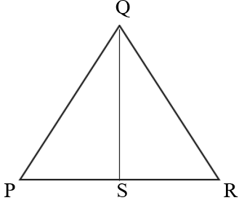
b. Given that triangles PQR and QSP are similar, PQ =$7.5 cm$ and QS = $3 cm$. The area of the triangle PQR is$50 cm^{2}$.

7.5cm

3cm

Find the area of triangle QSR. (4 marks)

Continued/…
- a. Prove that the exterior angle of a cyclic quadrilateral is equal to the interior opposite angle. (5 marks)

Continued/…

b. Solve the following equations simultaneously. (6 marks)
$$4p^{2}-q=23$$
$$p-q=9$$

- a. Factorise completely $y^{2}-7y+6$. (6 marks)

b. Using a pair of compasses and a ruler only, construct in the same diagram
- A circle centre O of radius 5cm
- A point P outside the circle and 10 cm from the centre O
- A tangent PT at T.
- Measure and state the value of angle OPT. (6 marks)

Continued/…
- a. An object starts from rest and reaches a speed of Vm/s as shown in figure 1 below.

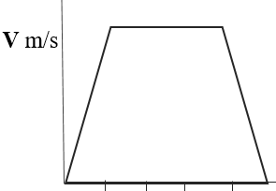
0 6 12 18 24 30
Time (s)
If the total distance covered was 570m, calculate the value of the speed, V.
(5 marks)

Continued/…
b. In figure 2, MO=4MR and RN=5RS. P is the midpoint of NO where MR= e, OM= f.
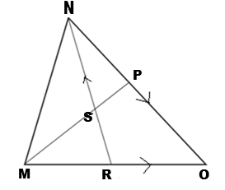
Figure 2
Express RO in terms of e and f. (4 marks)

Continued/…
Section B (40 marks)
Answer any four questions from this section in the spaces provided.
- Table 1 shows values of $x$ and $y$ for the equation
$y=x^{3}-3x^{2}-4x+5$.
$$x$$ | -2 | -1 | 0 | 1 | 2 | 3 | 4
$$y$$ | -7 |  | 5 | -1 |  | -7 | 5

- Complete the values of $y$ in the table. (2 marks)
- Using a scale of 2 cm to represent 1 unit on the horizontal axis and 2cm to represent 2 units on the vertical axis, draw the graph
of $y=x^{3}-3x^{2}-4x+5$. (4 marks)
- Use the graph in b to solve the equation
$x^{3}-3x^{2}+2x+12=0$ (4 marks)
Continued/…
- Figure below shows a solid block made from right cone and hemispherical top. The diameter of a hemisphere is 14 cm and angle PRQ = 60˚. (10 marks)

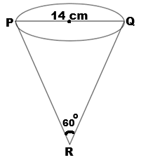
Find the total surface area of the solid block. (10 marks)

- A box contains 7 red marbles and 4 blue marbles. Two marbles are picked from the box at random one after the other without replacement.
a. Draw a tree diagram to represent this information. (5 marks)

Continued/…
b. Find the probability of picking two marbles of the same colour.
(5 marks)

- Solve the equation$2\left(2^{2y+1}\right)-8=4\left(2^{2y+1}\right)-18\left(2^{y}\right)$.
(10 marks)

Continued/…
- U-Fresh soap manufacturing company has five 5-tonne vans and four 10-tonne vans. A 5-tonne van carries 200 cartons of U-Fresh soap while a 10-tonne van carries 400 cartons of U-Fresh soap per day. The company wants to transport at least 1200 cartons of U-Fresh soap per day. The daily costs incurred in running the 5-tonne van and the 10-tonne van are K15 000 and K 45 000 respectively and the company must spend less than K 240 000 per day in order to meet the costs. If $x$ and $y$ are the numbers of 5-tonne vans and 10-tonne vans used each day respectively,

a. Write down four inequalities involving $x$ and $y.$ (4 marks)

b. Using 2cm to represent 2 units on $x$ axis and 2cm to represent 1 unit on the
$y$ axis, draw the graphs that satisfy the four inequalities on a graph paper
provided and shade the unwanted regions. (6 marks)

Continued/…


Continued/…
- The following are distances covered by different cyclists in a certain district.

22 3 17 9 25 20 18 9 14 4
12 22 14 19 17 18 9 12 18
13 12 2 25 18 17 19 16 14

a. Using the class intervals: 1-5, 6-10, 11-15… construct a frequency distribution table for the distances covered. (3 marks)

b. Using the frequency distribution table, find the modal class. (1 mark)

c. Using a scale of 2cm to represent 5 units on horizontal axis and 2cm to represent 2 units on the vertical axis, draw a histogram on the graph provided.
(6 marks)
Continued/…


END OF THE QUESTION PAPER
NB: This paper contains 13 printed pages

